Slime Fight ⚔️

1. Summary

1.1 Genre
Slime Fight will be a game where the player fends off hordes of enemies and tries to survive so this fits into a few genres such as:
- First person shooter (FPS)
- Horde/Wave-Survival
- Action game
- Tower defence hybrid

1.2 Synopsis
The game is mainly a first-person (with the ability to change to third person), wave-based defence experience set in a small village under attack. The player takes the role of a local slime who must protect their home from incoming enemies.
Each wave begins with a short story briefing that explains the situation and the player’s objective. The player starts outside or on the edge of the village and must prepare for incoming waves of enemies. Using movement, combat, and positioning, the player fends off waves of enemies.
Enemies arrive in increasing waves, becoming more difficult over time. The player must survive for as long as possible while protecting the environment and maintaining their health and resources.
The game is presented from a first-person perspective, allowing the player to interact directly with the world and enemies. Combat is simple and stylised, with enemies disappearing into smoke when defeated to maintain the game’s cartoon aesthetic.
Completing waves or surviving for a set period progresses the players providing them money allowing them to unlock upgrades to progress into further waves.

1.3 Target Audience
The game will primarily be 12+ or teens since there is some violence in terms of killing enemies so the audience should be somewhat mature as well as well as have some knowledge of proactive planning to progress and complete the game, though this may not be required if casually playing the game.

1.4 Game experience
The main aim of the game is survival of the player, they must be careful with their health being a resource as well as being cautious with their money allocation when loot drops from enemies as there will be consequences with taking too many risks. Players can usually be categorized into groups such as:
- Casuals – usually play the game on the fly, making decisions based on their own intuition. Hints or tips could be implemented to helping new players when losing game as well as a tutorial.
- Survivalists – these players prioritize staying alive in the game focusing on beating as many waves as possible whilst carefully keeping track of their own players survival making strategic adjustments. Adding bonus rewards when player is alive for x amount of time would reward this type of play style.
- Speed runners – players experience in playing the game as well as understanding its mechanics and exploits making the most optimal adjustments to clearing the game as quickly as possible. Skipping feature of some waves or adding a difficulties of the game would challenge these types of players.

1.5 MoSCoW
Here are some requirements implemented into the game based on priority sectioned into Must, Should, Could and Won’t Have
Must | Should | Can | Won’t
Menu UI | Health System | Different types of enemies | High quality professional meshes
Basic Movement/Camera | Combat System | Enemy move set | Advanced AI using neural networks
Waves of enemies | Sound/particle system | Player Skills | Online multiplayer
Basic Inventory | Basic Animation | Different weapon options | Overly complicated skill tree systems
Basic NPC + Enemy AI | Upgrades | Advanced enemy pathing/ai

[Figure 1: MoSCoW Requirements]

1.6 Unique Selling Points
Unlike traditional top-down survival games, this game delivers full third-person 3D swarm combat, where positioning, vertical terrain, and camera awareness directly affect survival.
- Enemies appear from any directions
- Elevation impacts strategy
- Terrain shapes combat flow
This creates a more immersive and reactive survival experience within the game that players can enjoy. You are also controlling a character, a Slime ,which in most games is usually an enemy or mob rather than a typical human character providing a new experience.

2. Background

2.1 Pixel Dungeon (2012), Character Selection
My character selection concept comes from Pixel Dungeon which similarly to typical rogue games has a character selection that the player chooses a character which restricts them to a certain playstyle due to the equipment or stats of different characters, each having their own strengths and weaknesses.
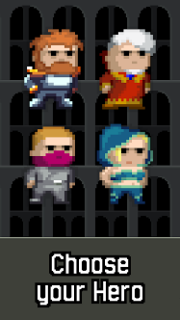
[Figure 2: Pixel Dungeon Character Selection Screen]

2.2 Diep.io (2016), Upgrades Skills
Like most games in survival upgrades are an important aspect to progression and survival of the player. Players must obtain exp points from defeating objects each level increase giving upgrade the points the player must use to increase their power, as the player increases in level these are harder to obtain.

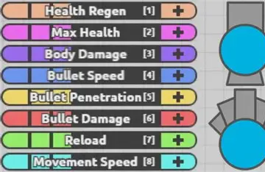
[Figure 3: Diep.io upgrade system]

2.3 Hollow Knight (2017) Upgrade Abilities
The innovation from abilities comes from Hollow Knights unique approach to aid player the player in defeating enemies and thus improve survival, this only being unlocked at certain stages of the story as well as requiring the player to careful use of their mana.
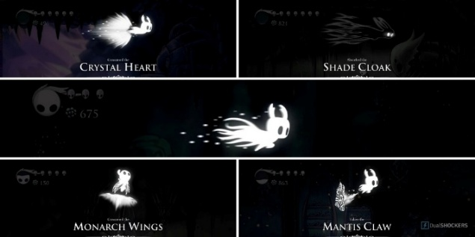
[Figure 4: Hollow Knight ability list]

2.4 Ace Attorney (2001), Story Portrayal
Representation of the player dialogue was inspired from visual novel aspect games such Ace Attorney where the character where a dialogue box is clear for the player to see and interact with to progress through the story. Making a simpler representation for the story rather than animating a full cutscene.
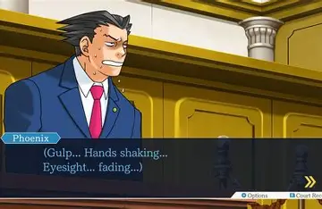
[Figure 5: Ace Attorney character dialogue]

3. Specification

3.1 Game Story
Your village is running out of supplies so you are assigned to go on a journey to the promised great slime kingdom, but the journey will be tough you will pass through many terrains, different encounters, can you survive and make it to the end of your journey?`

3.1.1 Player Story
You are just a slime, an ordinary slime, but rumours of the promised Slime kingdom emerge think about it - your village with be saved, you have better life, why wouldn’t you not take it. The game begins at the start of the journey in the forest.

3.1.2 General Story
The game begins at the point of the characters travel, where the enemies that appear are based on the terrain different points the player is at within the story.
The player is a Slime whose village is currently ongoing shortages of supplies – food, equipment, everything, one attack and its over .
Whispers spread of a distant Slime Kingdom - a rising civilization of slimes said to have everything you could ever want. Some say it is a beacon of hope, others say it’s just a false myth, but there is only one way to find out and its to see it yourself.
As you begin your journey towards the unknown this journey is now life or death there is no going back now.

3.2 Game Aesthetics
The aesthetics of this game will be mostly simple with some level of detail, using bright colours and a detail to the environment for a more immersive experience, this is done via the visuals, which will have some level of realism via some physics to the slime as well as some possible environmental effects like grass movement.
This approach is chosen to keep the art style visually appealing for players to visualise and immerse themselves in the world whilst some models may be kept simple to make the game not too performance intensive. Most assets added will follow the same colourful style to maintain a cohesive visual identity across the game.

3.3 Game Characters

3.3.1 Slime
The player, being a slime. Player Story in Section 3.11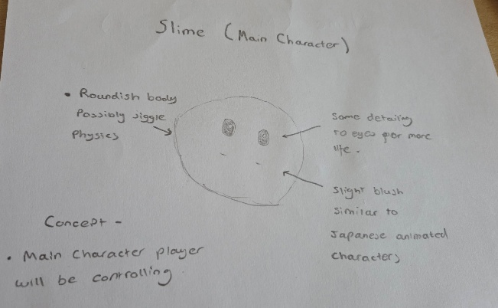

3.3.2 Enemies
Each terrain the player is in will have different enemies or a mixture of combined enemies reflecting the current point of the story the player is in, and all enemies will have the same mechanics to another – finding and killing the player.

3.4 Game Content
Each level will have a set number of waves, this will generate groups of enemies and will progressively get harder as the story progresses. Starting levels will take around 5 mins to complete whilst levels further into the game will take longer to around 20-30mins.
Some of these levels may include:

3.4.1 Forrest
[Figure 7 – Forrest Design]
Story
A gang of goblins block your path through the forest, their weapons raised and their intentions clear. They have claimed this stretch of woodland as their own, and they won’t let anyone pass unchallenged. If you want to move forward, you’ll have to fight your way through.
Gameplay
In this forest clearing, the player encounters a hostile group of goblins that initiate a wave-based combat scenario, the player must manage positioning, stamina and skills to make it through this level , they must make sure to beat all the waves without dying to complete the level successfully . The terrain can aid the player where there are clear spots for high ground or put the player in a disadvantage setting up ambushes from the goblins, it’s their territory after all.

3.4.2 Swamp
[Figure 8 – Swamp Design]
Story
Beyond the forest lies a thick, mist-covered swamp where anything moving is a threat as you make your way forward and seems the locals don’t quite like you, the swamp will defend itself from intruders and you seem to be one of them. If you want to pass through beat the source of the disruption.
Gameplay
Players must traverse through the muddy environment slowing them down and providing an opportunity for the enemies to pounce. The player must aim to kill the group leader enemy of each waves otherwise waves will keep spawning, the player should avoid the muddy terrain paths to avoid being overwhelmed as well as allocated resources to skills to make sure they can eliminate the leader as quickly as possible.

3.4.3 Badlands
[Figure 9 – Badlands Design]
Story
Beyond the swamp, the land begins to crack and dry. The vibrant greens of the forest fade, what’s left is only jagged rock formations, and rust-coloured dust storms that sweep across the horizon. This is the Badlands — a harsh unstable region where only true heroes can make it out.
Gameplay
This is the final stage for the player so will be the hardest, the player must fight through one wave of enemies then beat the final boss to win the game, to do this they must traverse away from the holes in the terrain as well as jump towards any obstacles to make there way to the boss at the end.

3.5 Game Mechanics

3.5.1 Movement
WASD directional movement typical in most first-person games.
Dash Mechanic - Short burst of directional movement that consumes stamina making sure the player makes careful usage as to when to use this.
Jump - Grants player access to elevated terrain or environmental advantages potentially allowing them to escape enemies.
Flight – Grants temporary flight for the player allowing them to either evade enemies or scout the area to their advantage – this only being unlockable via abilities.

3.5.2 Health System
The Health System defines the player’s current status and establishes the primary motive of continuing the game. Both enemies and players can regenerate their health overtime, for the player this requires allocation of coins to upgrade skills and improve this regeneration, enemies will also be able to regenerate health in the more advanced waves to prevent players playing a more passive style such as stalling.

3.5.3 Class Types
At the start of the game, the player can choose between two distinct class types. Each class offers different strengths and playstyles, allowing for varied combat:
Knight - The Knight is a close-range, combat for survivability and action on the frontlines which has
- Increased starting health
- Starts with sword
Archer - The Archer class focuses on ranged combat and keeping distance from enemies which has
- Lower starting health than the Knight
- Starts with bow

3.5.4 Upgrades/Abilities
In order to beat each wave, the player can purchase upgrades from the shop at any time given they have enough money dropped from the mobs from the waves, these give permanent affects that can help the player out throughout their playthrough of the game so selection is important an example of which being health boost increasing the players max health permanently increasing the chance of survival. Abilities will be more difficult to obtain either requiring a large amount of currency or objectives to be reached to obtain them, also having some skill to use due to cooldowns.

3.5.5 Enemy Spawn

Enemies spawn from fixed areas making combat more readable and strategic for the player. Instead of random enemies appearing anywhere, the player can learn where threats will emerge and position themselves, accordingly, encouraging movement and spatial awareness. This creates fair pressure, as players have time to react and plan their rotation around the arena.

3.5.6 AI Mechanics
In this wave-based system, enemies operate using a combat-focused state Upon spawning, enemies enter an active state, immediately seeking the player within a defined arena range. Basic units will path directly toward the player, while advanced types may flank, maintain distance, or attempt to zone. If the player moves beyond a set chase distance (arena boundary), enemies transition into a return State, navigating back toward their spawn origin to prevent kiting exploits.

4. Conclusion
Currently, I have implemented some core features within the game this being the character and the user interface for the game since this will be the first features of the game the player will actually see and interact with.
Character Implementation [Figure 11]
The played was created via following a tutorial in blender via Mix 3D – 『アブド 』 (2024) where a Slime model is creates by morphing a square object into a slime shape and applying some shaders which are then baked into the model so Unity can render the colours.
Character Movement (Third-Person WASD)
The character movement was implemented using Unity’s Character Controller component. This component handles collision detection and basic movement without requiring full physics simulation.
Unity’s Input System was used to manage player input. Input actions were created for movement and other controls, which were then linked to the character movement script. The system reads input from devices such as keyboard, mouse, or controller and converts it into movement values.
Slime Physics (Bouncy / Squash-and-Stretch Feel)
The slime physics were created following a tutorial from It's IT wala (2025) which demonstrated applying a cloth component onto an object via their mesh then I modified the cloth component variables until moving the character seem slime like.
Skybox (Environment Visualisation)
The environment was created using a cube map-based skybox. I imported premade textures from the Knight, R. (2021). and assigned each image to one of the six faces of a cube map (front, back, left, right, up, and down). These six images together form a 360° background that surrounds the camera.
The cube map was then applied to a Skybox material, which was set as the scene’s skybox in the Lighting settings. This makes the environment appear infinitely far away and ensures the camera is always inside it automatically.
UI Menu [Figure 12]
I first created some initial designs of the menu to have a general idea [Figure 10] , then created the actual menu using the built in Unity TextMeshPro components from creating a canvas then adding some text in places appropriate for the title and buttons via the Unity UI components, I also added a background video made by Muhammad ilham Marlis (2026) to make the start screen deem more animated and modern similar to how most game today have an animated start screen.

GitHub
Link: https://github.com/WilliamCheung2004/Slime-Fight-

Video Demonstration:
Link:

References
Mix 3D – 『アブド 』 (2024). How to create Anime slime material in blender | Blender Tutorial. [online] YouTube. Available at: https://www.youtube.com/watch?v=EqfjnzAG75E&list=PLV7AWvOndX37gteibnSqKjuTfZ2toeKHz [Accessed 20 Feb. 2026].
It's IT wala (2025). How to Create Soft Body Physics in Unity – Easy & Fun Tutorial! [online] YouTube. Available at: https://www.youtube.com/watch?v=uAKk3OzoOLk [Accessed 20 Feb. 2026].
Knight, R. (2021). Fantasy Skybox FREE. [online] @UnityAssetStore. Available at: https://assetstore.unity.com/packages/2d/textures-materials/sky/fantasy-skybox-free-18353?srsltid=AfmBOoo_6GH2nzRfX7zxjhX2YZlS84K1tOTo-bOa_HbyVSn2Dy5PtEwW [Accessed 20 Feb. 2026].
Muhammad ilham Marlis (2026). animation loop, forest with trees and green grass, cartoon style. [online] Vecteezy. Available at: https://www.vecteezy.com/video/45735117-animation-loop-forest-with-trees-and-green-grass-cartoon-style [Accessed 20 Feb. 2026].

Appendix A

[Figure 7]
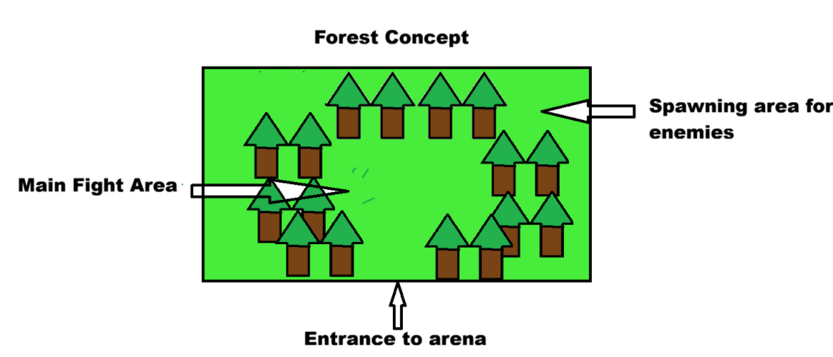

[Figure 8]
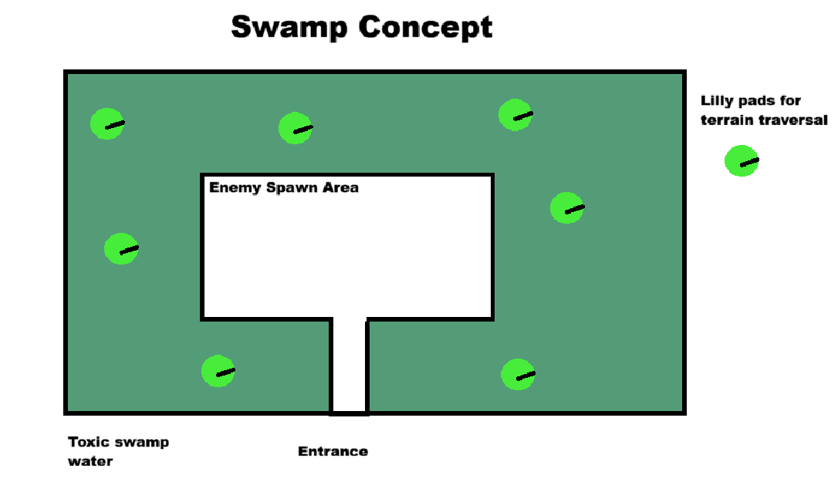

[Figure 9]
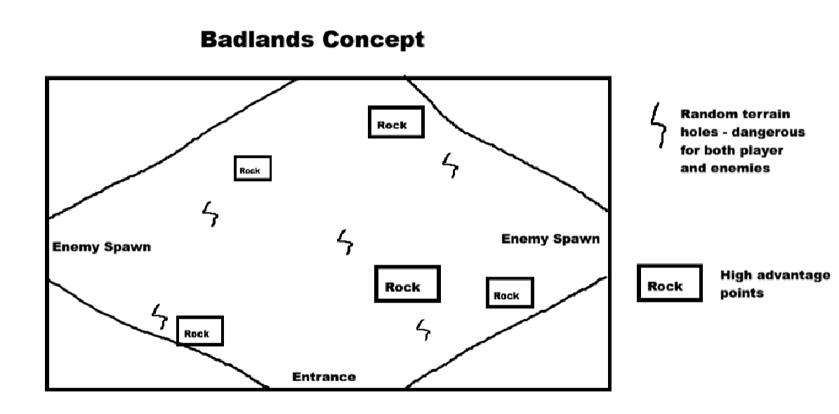

[Figure 10]
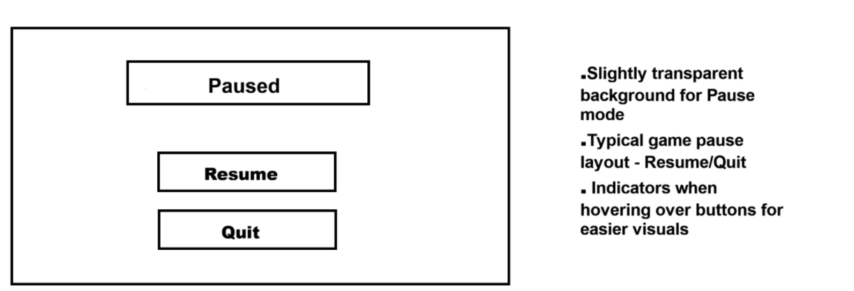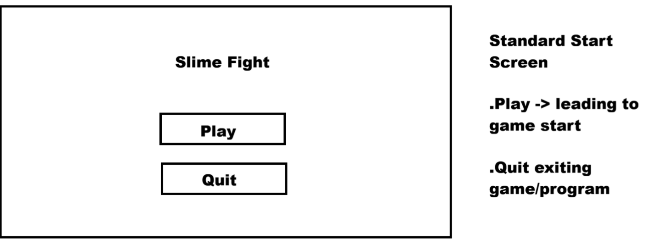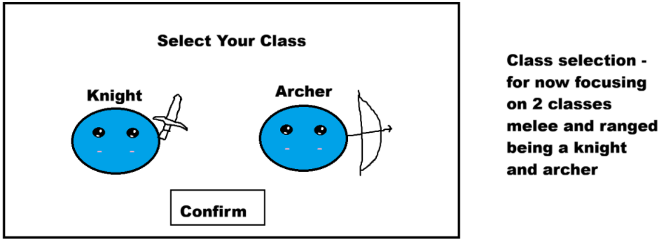

[Figure 11]
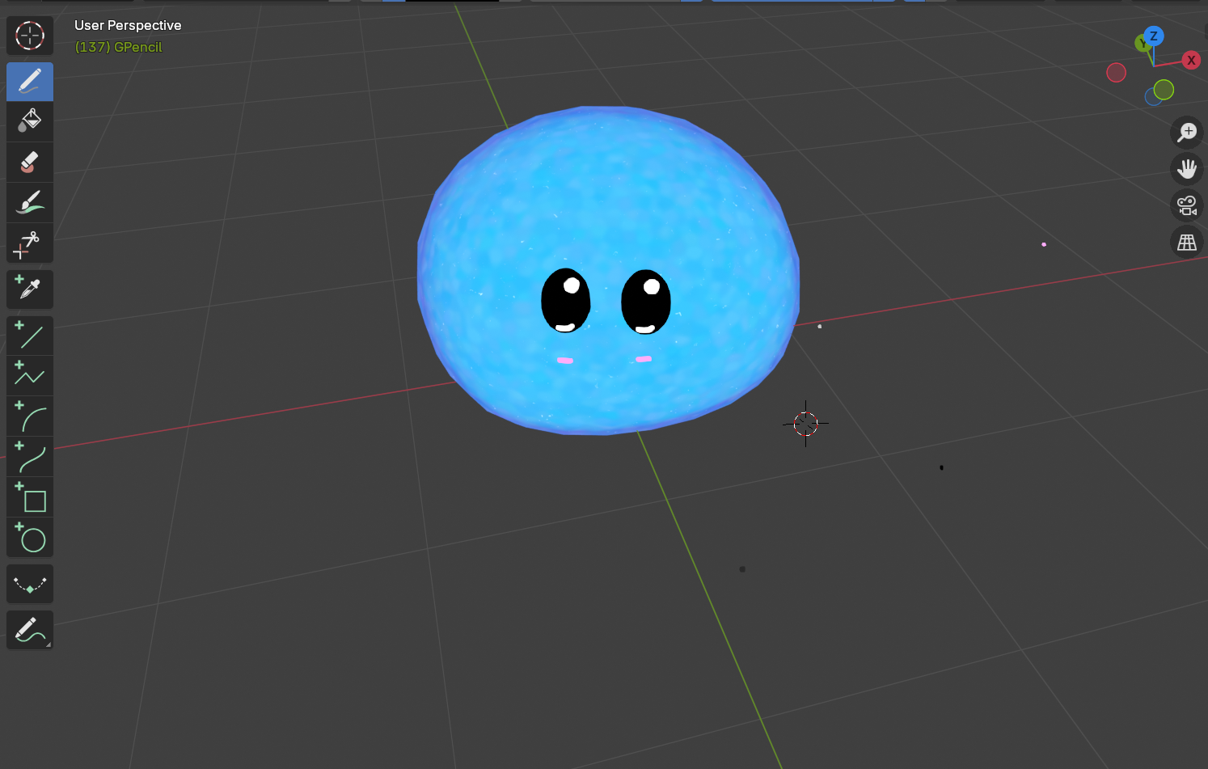

[Figure 12]
